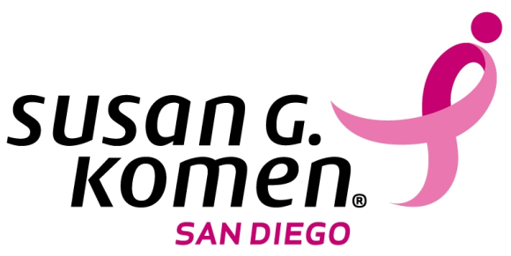
Digital Marketing Internship or Volunteer
San Diego County

Reports To: Director of Marketing and Communications
Department: Marketing
Part Time: 15-20 hours per week
Location: San Diego County, CA
Home office: San Diego, CA

Primary Purpose
Susan G. Komen San Diego is looking for a driven digital marketing intern. Your work will help Komen San Diego further there mission as the County’s largest funder of free breast cancer treatments and services, and is the only organization providing qualified women the free services they need for every step of the breast cancer journey.
Digital Marketing Internship Duties
- Update and present creative strategies to enhance the website
- Write and edit blogs
- Help provide content and strategic direction for Facebook, twitter, Instagram, LinkedIn and more
- Assist with web analytics tools and your own insights
- Assist with office management tasks as needed

Digital Marketing Internship Marketing Specialist Skills Required
- Marketing or Health background in college and/or real world experience (personal accounts with social media will not be considered as real world experience)
- Thorough understanding of Wordpress
- A thorough understanding of MS Office, including Word, Power Point, and Excel
- Excellent communication skills in person, over the phone, and in writing
- A passionate, positive, and willing-to-learn attitude
Hire Date: Immediately
- To Apply: Please send your resume and cover letter annie@sdkomen.org with: “Digital Marketing Internship” in the subject line. Qualified applicants will be contacted for an interview.
- Semester internships, this is an unpaid position.

